**Farmer’s Heaven**

**A Smart Web Portal for Crops Yield Estimation**

**Final Year Project**

**Session 2019-2023**

**A 4th Year Student**

A project submitted in partial fulfilment of the

COMSATS University Degree

Of

Software Engineering (CUI)



Department of Computer Science

COMSATS University Islamabad, Lahore Campus

6 February 2023

**Project Detail**

| Project ID (for office use) | | |  | | | | |
| --- | --- | --- | --- | --- | --- | --- | --- |
| Type of project | | | [ ]Traditional [ *] Industrial [ ] Continuing | | | | |
| Nature of project | | | [ *]**D**evelopment [ * ] **R**esearch [ * ] **R**&**D** | | | | |
| Area of specialisation | | | Web Application, Geographic information system (GIS) Development | | | | |
| **Project Group Members** | | | | | | | |
| Sr.# | Reg. # | Student Name | | CGPA | Email ID | Phone # | Signature |
| (i) | Sp19-bse-138 | Muhammad Zafar Ijaz Khan | | 2.94 | [Sp19-bse-138@cuilahore.edu.pk](mailto:Sp19-bse-138@cuilahore.edu.pk) | 03080000804 | zafar |
| (ii) | Sp19-bse-061 | Suleman Ahsan | | 2.80 | [Sp19-bse-138@cuilahore.edu.pk](mailto:Sp19-bse-138@cuilahore.edu.pk) | 03441054733 | Suleman |

# Plagiarism Free Certificate

This is to certify that, I am Muhammad Zafar Ijaz Khan S/D/o Muhammad Ijaz Iqbal Khan, group leader of FYP under registration no CIIT/Sp19-BSE-138/LHR at Computer Science Department, COMSATS Institute of Information Technology, Lahore. I declare that my FYP proposal is checked by my supervisor and the similarity index is 9% that is less than 20%, an acceptable limit by HEC. Report is attached here with as Appendix A.

Date: 1/12/2023 Name of Group Leader: Muhammad Zafar ijaz khan Signature: Zafar

Name of Supervisor: Mam Sara Muneeb Co-Supervisor (if any):____________________

Designation: Lecturer Designation: _____________________

Signature: _____________________ Signature: _____________________

HoD: _____________________

Signature: _____________________

**Abstract**

To make a website for farmers in which after sketching the location of their farms in a map, the farmer will get information about their field’s health and quality. This Application is a solution to better manage your farm(s) and optimize their production levels. Farmers can do yield estimation and check crop health from this website. This will increase the production of yield and beneficial for the farmers. This will be done through proprietary imagery-based algorithms to give farmers a clear image of the nature and state of their farm. Through this application farmers can track weather and take proper actions, monitor the temperature, humidity of the soil and can scan the weekly health status of their crops.

**Acknowledgement**

*We would like to thank our Teacher Ms.Sara Muneeb, who gave us this golden opportunity to work on a project based on Yield Estimation, and helped a lot in research base work despite her busy schedule. We are also thankful to One Clout Software house’ especially Sir Asim for proper guidance and providing us a platform where we can learn new skills. This project helped us to learn advanced technologies and techniques and do research base work, and enable us to be better at what we do. We also thank our family and friends for their support. This would not have been possible would them.*

(Zafar, Suleman)

Table of Contents

Plagiarism Free Certificate 2

List of Tables 8

1 Chapter 1: Introduction 11

1.1 Introduction 11

1.1.1 Farmer’s Heaven 11

1.1.2 Website 11

1.2 Objectives 12

1.3 Problem Statement 12

1.4 Assumptions & Constraints 12

1.4.1 Assumptions 12

1.4.2 Constraints 13

1.5 Project Scope 13

2 Chapter 2: Requirements Analysis 15

2.1 Literature review 15

2.1.1 APSIM crop model 15

2.1.2 Methods for estimating the yield 15

2.1.3 Remote sensing data 15

2.1.4 Internet of things 15

2.1.5 Technological techniques 16

2.2 Stakeholder List 16

2.3 Requirements Elicitation 17

2.3.1 Functional Requirements 17

2.3.2 Non-Functional Requirements 20

2.3.3 Requirements Traceability Matrix 22

2.4 Use Case Descriptions 23

2.5 Use Case Designs 36

2.5.1 Farmer Login 36

2.5.2 Farmer Signup 37

2.5.3 Farmer Profile 38

2.5.4 Yield Estimation 39

2.5.5 Create Farm 40

2.5.6 Choose Plot 41

2.5.7 Chat 42

2.5.8 Admin Sign in 43

2.5.9 Admin Profile 44

2.5.10 Admin Manage Farmer Data 45

2.5.11 Blog 46

2.6 Software development life cycle model 47

3 Chapter 3 System Design 49

3.1 Work Break down Structure (WBS) 49

3.2 Activity diagram 50

3.2.1 Create Farm 50

3.2.2 Farmer Login 51

3.2.3 Chat 52

3.2.4 Profile Setting 53

3.2.5 Yield Estimation 54

3.2.6 Blog 55

3.2.7 Register 56

3.2.8 Choose Plot 57

3.3 Sequence Diagram 58

3.3.1 Admin Log in 58

3.3.2 Farmer login 59

3.3.3 Profile 60

3.3.4 Yield Estimation 61

3.3.5 Create Form 62

3.3.6 Choose Plot 63

3.3.7 Chat 64

3.3.8 Blog 65

3.4 Software architecture 66

3.5 Class Diagram 67

3.6 Database diagram 68

3.7 ERD Diagram 69

3.8 Network Diagram 70

4 Chapter 4: System Testing 72

4.1 Test Cases 72

4.1.1 Draw Annotation 72

4.1.2 Sign In 73

4.1.3 Subscription 74

4.1.4 Logout 75

4.1.5 Chat 76

4.1.6 Admin Manage Farmer Data 77

4.1.7 Blog 78

5 Conclusion 80

5.1 Problems faced and lessons learned 80

5.2 Project summary 80

5.3 Future work 81

6 References 83

7 Plagiarism Report 85

8 Screenshots: 87

# List of Tables

Table 1 Farmer’s functional requirement 18

Table 2 Admin functional requirement 19

Table 3 Non-functional requirements 21

Table 4 Requirements traceability matrix 22

Table 5 Use case Sign In 23

Table 6 Use case Sign-out 24

Table 7 Use case Choose plot 25

Table 8 Use case Analyze Plot 26

Table 9 Use Case Monitor plot 27

Table 10 Use Case Yield Estimation 28

Table 11 Use Case Live Chat 29

Table 12 Use Case Subscription 30

Table 13 Use Case Manage Farmer Data 31

Table 14 Use Case Notification Alert 32

Table 15 Use Case Generate Pdf 33

Table 16 Use Case Add farm 34

Table 17 Use Case Blog 35

Table 18 Test case –Draw Annotation 72

Table 19 Test case – Sign In 73

Table 20 Test case –Subscription 74

Table 21 Test case –Logout 75

Table 22 Test case Chat 76

Table 23 test case Admin Manage Farmer Data 77

Table 24 Test case Blog 78

**List of Figures**

Figure 1 Use Case 1 Farmer sign in 36

Figure 2 Use Case Farmer sign up 37

Figure 3 Use Case 2 Farmer Profile 38

Figure 4 Use Case Yield Estimation 39

Figure 5 Use case 3 Create Farm 40

Figure 6 Use Case 4 Choose Plot 41

Figure 7 Use Case 5 Chat 42

Figure 8 Use Case 6 Admin Sign in 43

Figure 9 Use Case 7 Admin Profile 44

Figure 10 Use Case 8 Admin Manage Farm 45

Figure 11 Blog 46

Figure 12 Work Breakdown Structure 49

Figure 13 Activity Diagram Create Farm 50

Figure 14 Activity Diagram Farmer Login 51

Figure 15 Activity Diagram Chat 52

Figure 16 Activity Diagram Profile Setting 53

Figure 17 Activity Diagram Yield Estimation 54

Figure 18 Activity Diagram Blog 55

Figure 19 Activity Diagram Register user 56

Figure 20 Activity Diagram Choose Plot 57

Figure 21 Sequence diagram Admin login 58

Figure 22 Sequence diagram Farmer login 59

Figure 23 Sequence diagram Profile 60

Figure 24 Sequence diagram Yield Estimation 61

Figure 25 Sequence diagram Create Farm 62

Figure 26 Sequence diagram Choose Plot 63

Figure 27 Sequence diagram Chat 64

Figure 28 Blog 65

Figure 29 software architecture 66

Figure 30 Class diagram 67

Figure 31 Database diagram 68

Figure 32 ERD diagram 69

Figure 33 gantt chart 70

# Chapter # 1

# Introduction

# Chapter 1: Introduction

## Introduction

### Farmer’s Heaven

The agricultural sector plays an important role and has a momentous impact on the economies of Asian countries. As we know doing farming is complex business and farmers have to face different challenges like soil erosion, climate change, farm optimization, water supply on time etc. In the agriculture field, farmers are unaware of their field’s quality, health and quantity. While in the era of technology everything is possible with the help of technologies use Climate change has direct and indirect effects on agricultural productivity which include changing rainfall patterns, droughts, flooding, and the geographical redistribution of pests and diseases. Our application will help a farmer in much ways.This application will respond to the challenge of better estimating our crop production. Farmers will know when and how to irrigate and receive alerts when crops are under stress. Firstly the farmer has to register in our application and after login he has to give the location of his field. This application uses remote sensing to monitor agricultural land and it will provide yield estimation and crop area estimation on time. Images of the crops will be taken from satellites imagery and model will be train on the basis of images taken from satellites. This application will analyze his fields. So in this project we are providing our former community with insight into their fields. With the use of remote sensing Artificial intelligence and sentinel, it is possible to predict about crops yield estimation. After getting farmer farm origin we will apply some imaginary techniques of remote sensing and sentinel to get the exact location of the farmer farm .Then we will train the algorithm by providing some previous data to predict the exact yield estimation. Once farmers know about all these stuff they do some preventive action before doing something to escape of any future loss. If we look at our developed countries they are providing this facility to their farmer’s .Because as we know our mostly economy relies on agriculture then why do we not look at our agriculture field. By keeping all this fact and figure we are building this project which help our farmer and also help whose which is related to this field.

### Website

This is a web based application. User (farmer) has to create an account on the website. After login data like his form location, crops he harvested etc will be taken from famer or he can locate his farm /draw boundaries on maps provided by our website. After this his farm will be analyzed using remote sensing and weekly health reports will be given to farmers. Our website will also predict yield estimation, in which time water should be given, situation of land on different stages so that farmers can take action and get profitable yield on time. Our application will use proprietary imagery-based algorithms to give farmers a clear image of the nature and state of their soil/farm. Farmers will also get alert when to irrigate the soil, they can monitor their crops and do yield estimation. We take Normalized Difference Vegetation Index (NDVI) as a tool for crop health analysis and the use of remote sensing and historical data for yield prediction. NDVI is a widely used vegetation index that is calculated using the reflectance of red and near-infrared (NIR) wavelengths of light. NDVI values range from -1 to 1, with higher values indicating greater vegetation cover and health. NDVI is often used to monitor crop growth and development, identify crop stress, and detect areas of crop damage.

NDVI can be used to monitor crop growth by analyzing changes in NDVI values over time. Crop growth is associated with an increase in NDVI values as the crop canopy expands. NDVI can also be used to identify crop stress caused by factors such as water stress, nutrient deficiencies, and pest infestations. Crop stress is often associated with a decrease in NDVI values. NDVI can also be used to detect areas of crop damage caused by pests and diseases. Damage is often associated with a decrease in NDVI values in specific areas of the field.

For prediction remote sensing and historical data together can improve the accuracy of yield predictions. Remote sensing provide detailed information on crop growth and development, while historical data can provide a broader perspective on how crop yields have been affected by weather and other factors in the past.

## Objectives

Identifying and mapping areas of crop damange caused by pests and disease

Monitoring crop growth and development

Providing early warning of potential crop failure

Improving crop management and decision making through accurate and timely data

Free application so that everyone can experience

Our application will provide actionable insights to give you enough time to react and help prevent damages, as well as better manage the farm and increase the amounts of viable production.

## Problem Statement

Many farms do not realize their profitability potential due to a uniform management of inputs and operations. Our application will provides youweekly diagnosis of your cropswith the help of satellite remote sensing. Also farmers don’t have an idea how much yield they will get from farms. Our application will provide yield estimation of the field and give alert to climate change so that farmers should be aware and take prerequisite activities.

## Assumptions & Constraints

### Assumptions

Assumptions of the project are following:

1. All the necessary tools will be available
2. Members will have grip on required technologies.
3. The scope of the project will be completed on time.
4. All the team members will be available.
5. Performance of project members will be adequate.
6. Skills of project members will improve during the development of this project.
7. We assume our project will help farmers in increasing the yield of crops.
8. Video tutorials will be provided so that farmers will not face issues in using tools of application.
9. Agriculture plays a major role in economic growth and development so advanced technologies and tools used in this application will help to improve productivity.

### Constraints

Constraints of the Projects are following:

1. Development of a project must be completed in given timeframes and deadlines.
2. The development of a project must fully follow defined project scope.
3. The language used in the website will be English.
4. There are some limitation for image-based remote sensing application like restricted spectral range, very slow turnaround time and coarse spatial resolution
5. The application will only work with internet connection.

6. Domain requirements must be addressed completely.

## Project Scope

The project will be able to help the farmer for better harvesting and increase in production. The farm will be analyzed using remote sensing and a weekly health report will be given to the farmer. Our website will predict yield estimation .we will enable farmer to look prior condition and circumstance of his farm so that by keep in view these plant their crops or better yield .In the future we aim to extend the application   with some more useful feature to increase productivity in crops (e.g weather tracker ,capacity probe etc ) also convert web app into mobile app .

# Chapter# 2

# Requirements Analysis

# Chapter 2: Requirements Analysis

## Literature review

### APSIM crop model

The work in this paper specializes in a method that makes use of the agricultural production structures simulator plant version which mimics plant life existence responses to the surroundings conditions and for compiling records it uses particle filtering. After applying the again-to-returned retrospective to the predictions of the APSIM LAI model after one simulation step, an outstanding settlement became reached for as compared to the yield gathered within the discipline. Importantly, this technique does not use any internal data of yield to estimate the retrospective model and indicates that even with an unmarried dimension measure; it's possible to predict yield estimates with correct accuracy up to a few weeks earlier than the recognized “deferred” date. Without the want to watch for the actual satellite to bypass  -biophysical related each or within combination (i.e. multi-variable assimilation). In-discipline statistics has been the focus of research for many years, currently the emergence of perceptions with the important local-temporary decisions, in addition to powerful comparisons to combine this. Modeling systems are in the region to enhance crop prediction efforts. That dating is then used to indicate the right date for the retreat whilst LAI gives the pleasant yield prediction: in this case, about 14 weeks earlier than harvest. In place of the usage of a retrofit on a satellite image that corresponds to, or closest to, the opposite date, the approach uses a particle filter that consists of cube Sat-based LAI into APSIM to offer stop-of-season crop maps (three m) weeks before the ideal reversal date. [1]

### Methods for estimating the yield

The research in this paper focuses on two methods of measuring yields of various crops in Hungary using satellite sensor data. The new Plant Index (General Yield Unified Reference Index (GYURI)) was obtained using the double Gaussian curve of growing data from the National Oceanic and Atmospheric Administration (NOAA) Advanced Ultra High Resolution Radiometer (AVHRR).The correlation between GYURI and 3-year cornfield data was R 2 = 0.75. The second method introduced uses only NOAA AVHRR and the officially reported yield levels of the region. Regional-level yield data and crop indicators obtained, GYURI, surveyed eight different crops over eight years. A well-developed method has proven to be a stable and accurate method that can be used to measure yields in regions, regions and countries.[2]

### Remote sensing data

According to the research report, there are many yield estimation methods used internationally, but the most effective are those based on remote sensing data and techniques. These problems make the crop production process less efficient and less efficient. Due to many restrictions such as weather conditions (cloud cover percentage) and few temporary adjustments, the remote sensor data needed to estimate yield does not take much time.[3]

### Internet of things

According to a research paper, in Precision Agriculture, authors often use expensive soil and crop health monitoring techniques such as satellite imagery and aircraft. This document describes an online real-time in situ farming (IoT) device designed to monitor soil and environmental conditions. Designed to be compatible with open computer systems, the device consists of temperature and humidity (soil and ambient), soil and light flux, Global Positioning System (GPS), and sensors for ZigBee wireless communication. I am. Soil temperature, moisture, and conductivity measurements are used to monitor soil conditions. Local area data can be used to support decisions related to irrigation and other crop health issues. [4]

### Technological techniques

In this research paper, the author focuses on technical techniques such as data visualization and GIS analysis. The design and construction of this technology, model decision-making system, will help local leaders analyze land use and determine possible interventions to address land use issues that affect the community. This study assesses the state of agricultural land in Catanduanes by visualizing and analyzing it in a spatial study that determines the state of agricultural knowledge in Catanduanes. Analysis of the state's agricultural land shows that it is resistant to climate change, drought and lack of irrigation facilities. These farmlands require the quality and quantity needed to reduce living conditions and urban growth in order to transform commercial areas. The results of the survey will help local leaders prioritize agriculture and consider and develop appropriate policies and procedures to protect farmland during land reform, use and expansion. [5]

## Stakeholder List

Following is the list of project stakeholders:

* **Admin:** Admin will manage data of farmers and check activities of the farmers.
* **Farmer:** farmers will interact with websites to get the diagnosis of their fields and complete insight of the fields.

|  |  |  |  |
| --- | --- | --- | --- |
| **Actors** | **Computer knowledge** | **Domain knowledge** | **Frequency of Use** |
| Farmer | Good knowledge about the web. | He should know how to use website, draw boundaries of farm on the map | Frequent |
| Admin | Better knowledge about the web. | Has good knowledge about domain. | Frequent |

*Table 1 Stakeholder List*

## Requirements Elicitation

### Functional Requirements

#### Farmer’s functional requirement

|  |  |
| --- | --- |
| **Fr no** | **Definition** |
| **FR1** | **Sign in** |
| FR1-01 | Farmers login to website with username and password. These credentials are check in database after then authenticated users are allowed to sign in to the website. |
| **FR2** | **Sign up** |
| FR2-1 | Farmers can sign up with their username, email, location and password. |
| **FR3** | **Sign out** |
| FR3-1 | Farmers can sign out from account. |
| **FR4** | **Choose  Plot  from map/upload geojson file** |
| FR4-1 | After login,Ther farmer is redirected to the dashboard where the farmer will see a map and he will choose a plot on map or if he has a geojson file he can also upload it. |
| **FR5** | **Analyze plot** |
| FR5-1 | After Farmer has provided details of the plot on the map .Farmer will analyze his plot and see the weekly basis condition of his farms. |
| **FR6** | **Monitor plot** |
| FR6-1 | System will provide current situation of the plot by remote sensing and satellite imaginary and thru these details framer will monitor their plot. |
| **FR7** | **Yield Estimation** |
| FR7-1 | Yield estimation of crop with estimate quantity of the farm will be given to the farmers through this website. |
| **FR8** | **Live Chat** |
| FR8-1 | Farmers can contact and do live chat with the support team. Thru live chat user can solve their quires regarding his issues. |
| **FR9** | **Subscription** |
| FR9-1 | Farmers have to buy a monthly or yearly subscription of the website. After subscription farmer will have access to all the tools in the website. |
| **FR10** | **Alert/Notification (about chat , weather condition and related to yield estimation )** |
| FR10-1 | Farmers will get alerts on weather conditions ,water supply time etc. |
| **FR11** | **Generate pdf of farm related data** |
| FR11-1 | Farmer can generate a pdf of his farm with information of his plot and yield estimation. |
| **FR12** | **Add farm/multiple farm** |
| FR12-1 | Farmers will add single or multiple farms and monitor it by detecting their location. |
| **Fr13** | **Blog** |
| Fr13-1 | Farmer will read blog post by Admin |

Table 1 Farmer’s functional requirement

#### Admin functional requirement

|  |  |
| --- | --- |
| **FR no** | **Definition** |
| **FR1** | **Sign in** |
| FR1-1 | Admin can login to account with valid username and password. |
| **FR2** | **Manage Profile** |
| FR2-1 | Admin can edit his profile and manage it. |
| **FR3** | **Sign out** |
| FR3-1 | Admin can sign out from account. |
| **FR4** | **Manage Records** |
| FR4-1 | Admin will manage records of the farmers. Admin can edit delete or modify record of the user. |
| **FR5** | **Give Subscription** |
| FR5-1 | Admin will give subscriptions to the farmers. After taking subscription user will have access to all the tools. |
| **Fr6** | **Announcements** |
| FR6-1 | Admin will give notification and announcement of features which will be newly added in future. |
| **Fr7** | **Blog** |
| Fr7-1 | Admin will add text, images, and other media to the blog,and notify new updates in portal. |

Table 2 Admin functional requirement

### Non-Functional Requirements

|  |  |
| --- | --- |
| **N-F-R** | **Definitions** |
| **NFR1** | **Security** |
| NFR1-1 | The system will run on safe server. |
| NFR1-2 | The system will not share user data with anyone |
| NFR1-3 | Validation should be done of every input from user. |
| NFR1-4 | Data integrity shall be checked. |
| NFR1-5 | The system will provide security updates regularly. |
| **NFR2** | **Safety** |
| NFR2-1 | The system will work without catastrophic failure. |
| NFR2-2 | Database should have backup as the data base might get crashed on critical condition of server or for unconscious reasons. |
| NFR2-3 | In the event of a system failure, data security can be insured as it continues to back up regularly. |
| **NFR3** | **Maintainability** |
| NFR3-1 | The system should be maintainable. The system should deduct bugs and errors and notify the user. |
| NFR3-2 | The system should be updated regularly and maintained to avoid bugs. |
| **NFR4** | **Performance** |
| NFR4-1 | Response time of software should not exceed more than 5 seconds. |
| NFR4-2 | The database should have capacity to save 100000 records of data. |
| NFR4-3 | Users will access the website at any time. |
| **NFR5** | **Implementation** |
| NFR5-1 | The software should be implemented to work as a web application after than it will be shifter to mobile application. |
| **NFR6** | **Reliability** |
| NFR6-1 | The software shall be reliable. |
| NFR6-2 | Downtime of the website should not exceed more than 6 hours. |
| **NFR7** | **Compatibility** |
| NFR7-1 | The software shall be compatible with different devices. |
| **NFR8** | **Usability** |
| NFR8-1 | Interface provided to user should not be complex; it should be simple and understandable.  The system design should be simple and friendly |
| NFR8-2 | The interface should be easy to learn. |

Table 3 Non-functional requirements

### Requirements Traceability Matrix

|  |  |  |  |  |  |  |
| --- | --- | --- | --- | --- | --- | --- |
| **Req** | **Descriptions** | **WBS Deliverables** | **Use** **Cases** | **Priority** | **Working** | **Test** **Cases** |
| FR1 | The user must log in to his account | 1 | UC001 | HHh High | O In progress | Jj j-4.1.2 |
| FR2 | the user may sign-out into their account | 2 | UC003 | High | In progress | 4.1.4 |
| FR3 | farmer may select plot from the map | 2.15 | UC003 | High | In progress | 4.1.1 |
| FR4 | Farmer may analysis the plot and sees the condition of the farm. | 2.11 | UC004 | High | In progress | - |
| FR5 | farmer can monitor his plot | 2.12 | UC005 | High | In progress | - |
| FR6 | farmer can estimate his crop yield | 2.13 | UC006 | High | In progress | 4.1.8 |
| FR7 | Farmer can chat with support team. | 2.14 | UC007 | High | In progress | R44.1.5 |
| FR8 | farmer must have to buy the subscription to use the website tools | 2.1 | UC008 | L  Low L | In progress | 4.1.3 |
| FR9 | Farmer can add single or multiple farms on map | 2.1 | UC009 | Low | In progress | 4.1.7 |
| FR10 | Farmer will get alert on weather condition | 2.8 | UC010 | High | In progress | - |
| FR11 | farmer can generate pdf of their form data | 2.11 | UC011 | Low | In progress | - |
| FR12 | Admin will manage form data | 2.2 | UC012 | High | In progress | 4.1.6 |

Table 4 Requirements traceability matrix

## Use Case Descriptions

|  |  |
| --- | --- |
| **Use Case ID** | UC 1 |
| **Name** | Sign In |
| **Actors** | Farmer ,Admin |
| **Summary** | Actors(farmers,admin) login to the website with valid credentials. |
| **Pre-conditions** | |
| The admin/farmer must have an account on the farmer’s heaven website. | |
| **Post Conditions** | |
| Success | After the user is logged into the account then it is redirected to the dashboard where he can see the map. |
| Failure | The user is unable to sign in due to some reasons. |
| **Normal Course of Events** | |
| The sign in process starts when the user click on Login page of the application he clicks “Login page” on the initial screen.   1. The web portal required login credentials from user. 2. The farmer fills in the required information 3. The web portal checks and validates credentials from the database and logs the farmer into their account. 4. Sign in process close. | |
| **Alternate Flows** | |

Table 5 Use case Sign In

|  |  |
| --- | --- |
| **Use Case ID** | UC2 |
| **Name** | Log Out |
| **Actors** | User |
| **Summary** | A user logs out of his account from the website. |
| **Pre-conditions** | |
| The user must first log into their account. | |
| **Post Conditions** | |
| Success | The user is logged out from his account successfully. |
| Failure | None |
| **Normal Course of Events** | |
| The use case starts when a farmer is logged in to the portal and selects the “LogOut” button on the navbar.   1. The portal logs out of the account once the farmer selects the logout  link.. 2. The portal then push the  farmer to the first render sign In screen 3. The log out case ends. | |
| **Alternate Flows** | |
| None | |

Table 6 Use case Sign-out

|  |  |
| --- | --- |
| **Use Case ID** | UC3 |
| **Name** | Choose plot |
| **Actors** | Farmer |
| **Summary** | Choose the plot of the farm in the map provided in the dashboard after login in the website. |
| **Pre-conditions** | |
| The farmer should be signed in to the account first and needs to choose the area of plot in the map. | |
| **Post Conditions** | |
| Success | The famer successfully selects the plot. |
| Failure | None |
| **Normal Course of Events** | |
| This process starts when the farmer chooses the area of plot.   1. The farmer selects the plot by tools given in the interface. 2. Farmers draw boundaries around the plot and save. 3. Farmers upload json data if he doesn’t know exact location of his plot | |
| **Alternate Flows** | |
| 1. The farmer does not select plot and instead try to assess other pages. | |

Table 7 Use case Choose plot

|  |  |
| --- | --- |
| **Use Case ID** | UC4 |
| **Name** | Analyze Plot |
| **Actor(s)** | Famer |
| **Summary** | Farmer will analyze plot by tools provided to him in the dashboard. |
| **Pre-conditions** | |
| Farmer must be login and have buy his monthly subscription | |
| **Post Conditions** | |
| Success | The farmer overview the condition of the field and suggestions will be given to the farmer by our trained model. |
| Failure | None |
| **Normal Course of Events** | |
| This process starts when the farmer logs in to the account   1. The new recommendation is displayed on the initial dashboard screen. 2. The farmers see the details and latest information of their crops. 3. The use case ends. | |
| **Alternate Flows** | |
| None | |

Table 8 Use case Analyze Plot

|  |  |
| --- | --- |
| **Use Case ID** | UC5 |
| **Name** | Monitor plot |
| **Actor(s)** | Farmer |
| **Summary** | Farmer will be updated by the health of the crops and he will monitor it. |
| **Pre-conditions** | |
| None | |
| **Post Conditions** | |
| Success | The farmer monitors his farms on weekly basis. |
| Failure | None |
| **Normal Course of Events** | |
| The use case starts when the farmer draw boundaries of the plot on the map and tell the crop name.   1. The farmer will get early updates of the weather and crop health. 2. End. | |
| **Alternate Flows** | |
| None | |

Table 9 Use Case Monitor plot

|  |  |
| --- | --- |
| **Use Case ID** | UC6 |
| **Name** | Yield Estimation |
| **Actors** | Farmer |
| **Summary** | Get information of the estimated yield before harvesting the crop. |
| **Pre-conditions** | |
| None | |
| **Post Conditions** | |
| Success | Farmers know about their crop health and yield estimation. |
| Failure | None |
| **Normal Course of Events** | |
| The use case starts when the farmer provides detail of the plot ,algorithm will run and give estimation of the yield. | |
| **Alternate Path** | |
| None | |

Table 10 Use Case Yield Estimation

|  |  |
| --- | --- |
| **Use Case ID** | UC007 |
| **Name** | Live Chat |
| **Actors** | User/Admin |
| **Summary** | User can chat with the admin and get information, solve the problems. |
| **Pre-conditions** | |
| None | |
| **Post Conditions** | |
| Success | User can chat with support team. |
| Failure | None |
| **Normal Course of Events** | |
| This process starts when the farmer is facing a problem and does not know how to resolve it.   1. User will click on the chat button and contact the support team. 2. Ends. | |
| **Alternate Path** | |
| None | |

Table 11 Use Case Live Chat

|  |  |
| --- | --- |
| **Use Case ID** | UC8 |
| **Name** | Subscription |
| **Actor(s)** | Farmer |
| **Summary** | Farmers have to buy a monthly or yearly subscription of the website. |
| **Pre-conditions** | |
| None | |
| **Post Conditions** | |
| Success | After buying a subscription He will be able to assess different tools and data about his field from the website. |
| Failure | None |
| **Normal Course of Events** | |
| The use case starts when the farmer buys a subscription ,and has access to a map and different tools of yield estimation .   1. The farmer after paying will assess data and tools. 2. Ends. | |
| **Alternate Path** | |
| None | |

Table 12 Use Case Subscription

|  |  |
| --- | --- |
| **Use Case ID** | UC9 |
| **Name** | Manage Farmer Data |
| **Actor(s)** | Admin |
| **Summary** | Admin will manage farmer data after getting back by train model and keep record of that data .Then deliver to related farmer. |
| **Pre-conditions** | |
| None | |
| **Post Conditions** | |
| Success | Admin will manage data of the farmer |
| Failure | None |
| **Normal Course of Events** | |
| The use case starts when Admin login.   1. By clicking particular farmer data he will get a record of that data. 2. Ends. | |
| **Alternate Path** | |
| None | |

Table 13 Use Case Manage Farmer Data

|  |  |
| --- | --- |
| **Use Case ID** | UC10 |
| **Name** | Notification Alert |
| **Actors** | Farmer |
| **Summary** | A notify icon which informs farmer about the notification from the admin |
| **Pre-conditions** | |
| User should allow app to send notification on the website. | |
| **Post Conditions** | |
| Success | The Farmer receives notifications from the admin successfully. |
| Failure | None |
| **Normal Course of Events** | |
| This process starts when the farmer presses the notify icon feature.   1. The farmer clicks the notification bell icon. 2. The farmer views different notifications received from the admin. 3. Ends. | |
| **Alternate Path** | |
| None | |

Table 14 Use Case Notification Alert

|  |  |
| --- | --- |
| **Use Case ID** | UC11 |
| **Name** | Generate Pdf |
| **Actors** | Farmer |
| **Summary** | The farmer gets data in pdf form and he can download it . |
| **Pre-conditions** | |
| The farmer must be logged into the account and generate pdf. | |
| **Post Conditions** | |
| Success | After generating the pdf the farmer has full data about his farm and he prints it out. |
| Failure | He can only generate pdf when he has plotted his area on map and mention what he wants to do with this plotted area. |
| **Normal Course of Events** | |
| The use case starts when the farmer has access to the dashboard after buying the subscription.   1. The farmer generates a pdf by clicking on the generate pdf button. 2. The use case ends. | |
| **Alternate Path** | |
|  | |
|  | |

Table 15 Use Case Generate Pdf

)

|  |  |
| --- | --- |
| **Use Case ID** | UC012 |
| **Use Case Name** | Add farm/multiple farm |
| **Actor(s)** | Farmer |
| **Summary** | The farmer can add single or multiple farms to get yield estimation. |
| **Pre-conditions** | |
| The farmer must be purchased subscription and must be logged in . | |
| **Post Conditions** | |
| Success | He can successfully add single/multiple farms by buying subscriptions. |
| Failure | The farmer is unable to add farm. |
| **Normal Course of Events** | |
| The use case starts when farmer has buy subscription and want to add farms     1. He can add single or multiple farms. 2. He can manage data 3. The will get weekly report of his farm. | |
| **Alternate Path** | |
|  | |

Table 16 Use Case Add farm

|  |  |
| --- | --- |
| **Use Case ID** | UC8 |
| **Name** | Blog |
| **Actor(s)** | Admin |
| **Summary** | Admin will have the ability to add text, images, and other media to the blog. |
| **Pre-conditions** | |
| None | |
| **Post Conditions** | |
| Success | After login admin will write blog,it will be shown on the website. |
| Failure | None |
| **Normal Course of Events** | |
| This process starts when  1. Logging in: Using a username and password, an administrator would log in to the dashboard.  2. Navigating to the content creation page: From the admin dashboard, the administrator would navigate to the page where they can create new blog posts. This may be called something like "Write a new post" or "Create content."  3. Creating a new post: The administrator would then begin creating a new blog post by adding a title, the body of the post, and any necessary media such as images or videos. Formatting the post: Administrator will format the post, such as adding headings, lists, and links.  4. Previewing the post: Before publishing, the administrator would preview the post to ensure that it looks and reads correctly.  5. Publishing the post: The administrator would then publish the post, making it live and accessible to readers on the website. | |
| **Alternate Path** | |
| None | |

Table 17 Use Case Blog

## Use Case Designs

### Farmer Login



Figure 1 Use Case 1 Farmer sign in

### Farmer Signup



Figure 2 Use Case Farmer sign up

### Farmer Profile



Figure 3 Use Case 2 Farmer Profile

### Yield Estimation



Figure 4 Use Case Yield Estimation

### Create Farm



Figure 5 Use case 3 Create Farm

### Choose Plot



Figure 6 Use Case 4 Choose Plot

### Chat



Figure 7 Use Case 5 Chat

### Admin Sign in



Figure 8 Use Case 6 Admin Sign in

### Admin Profile



Figure 9 Use Case 7 Admin Profile

### Admin Manage Farmer Data



Figure 10 Use Case 8 Admin Manage Farm

### Blog



Figure 11 Blog

## Software development life cycle model

After detailed research on our project we have decided to use Incremental Model. The reasons for choosing this model is

1) There are multiple deliverables involved in between the process of software development.

2) The requirements have been properly drafted by the analyst, so there is no need to change any requirements.

3) The team is small in number, so they can start working on each module development by taking up one phase each member based on the priority set by customer.

4) The software is broken into several independent functional units which are loosely coupled.

5) Each fragment can be delivered independently based on the deadline.

6) The team can split into groups for each phase and finish the build as required.

* 7) Highest priority requirement is tackled first.

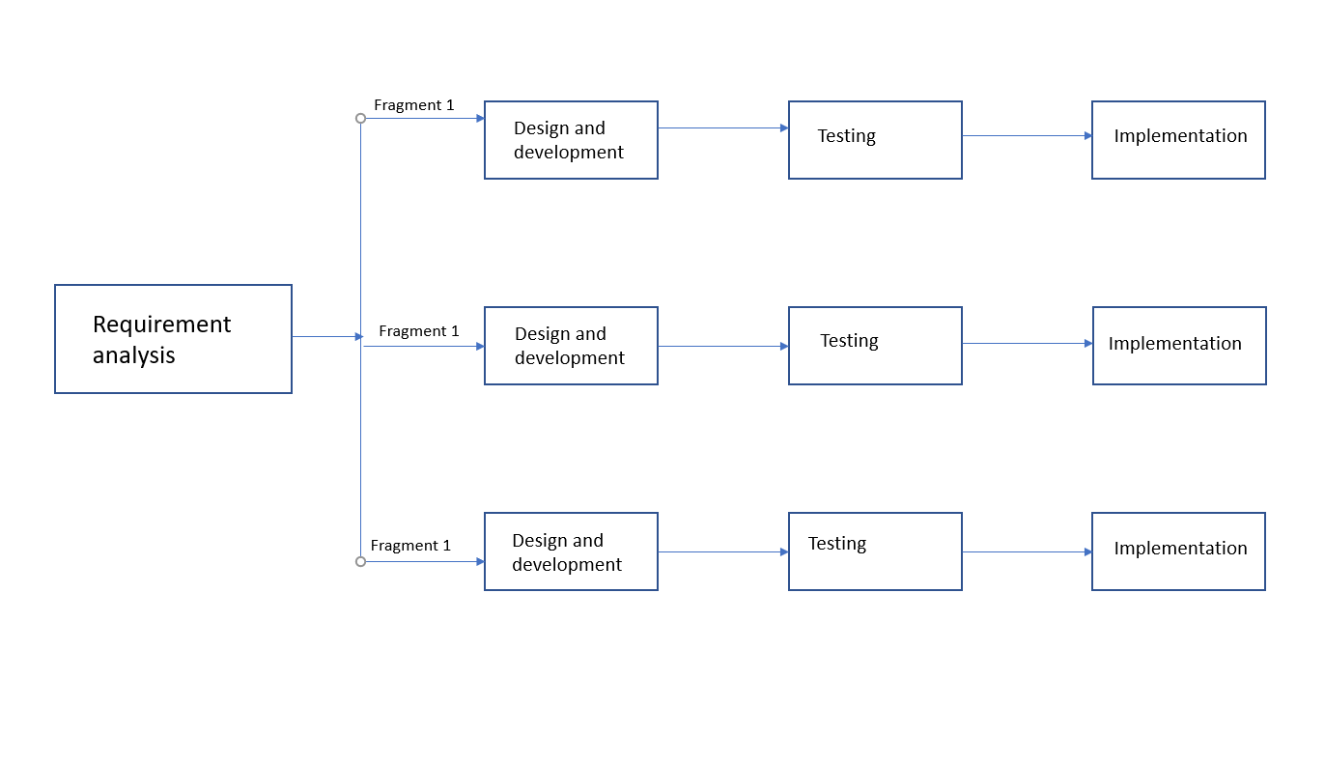

# Chapter #3

# System Design

# Chapter 3 System Design

## Work Break down Structure (WBS)

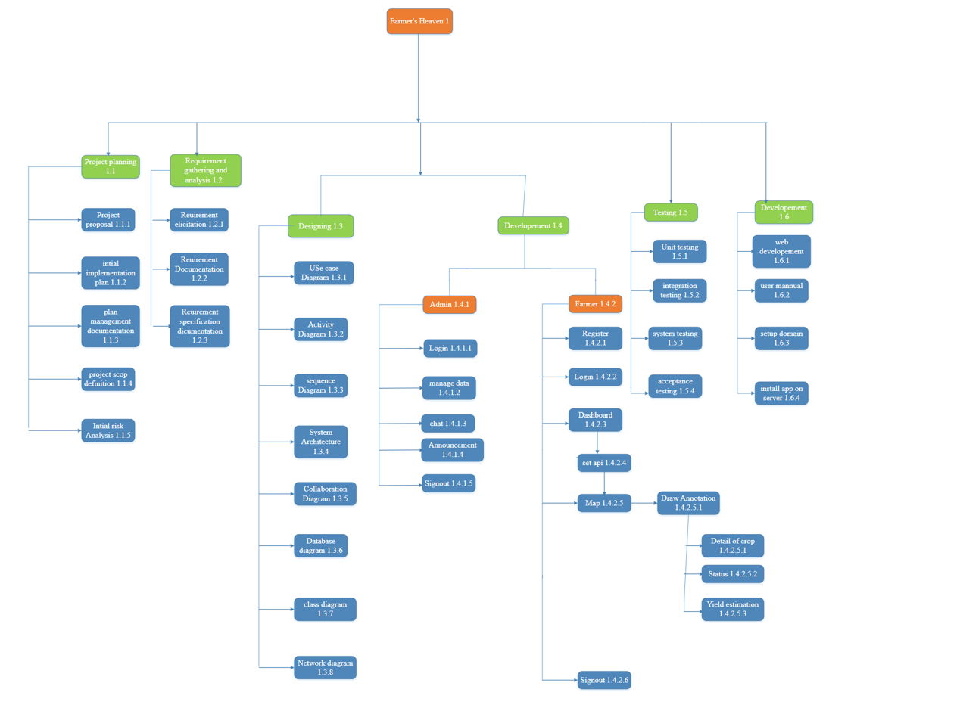

Figure 12 Work Breakdown Structure

## Activity diagram

### Create Farm



Figure 13 Activity Diagram Create Farm

### Farmer Login



Figure 14 Activity Diagram Farmer Login

### Chat



Figure 15 Activity Diagram Chat

### Profile Setting



Figure 16 Activity Diagram Profile Setting

### Yield Estimation



Figure 17 Activity Diagram Yield Estimation

### Blog



Figure 18 Activity Diagram Blog

### Register



Figure 19 Activity Diagram Register user

### Choose Plot



Figure 20 Activity Diagram Choose Plot

## Sequence Diagram

### Admin Log in



Figure 21 Sequence diagram Admin login

### Farmer login



Figure 22 Sequence diagram Farmer login

### Profile



Figure 23 Sequence diagram Profile

### Yield Estimation



Figure 24 Sequence diagram Yield Estimation

### Create Form



Figure 25 Sequence diagram Create Farm

### Choose Plot



Figure 26 Sequence diagram Choose Plot

### Chat



Figure 27 Sequence diagram Chat

### Blog



Figure 28 Blog

## Software architecture



Figure 29 software architecture

## Class Diagram



Figure 30 Class diagram

## Database diagram



Figure 31 Database diagram

## ERD Diagram



Figure 32 ERD diagram

## Network Diagram

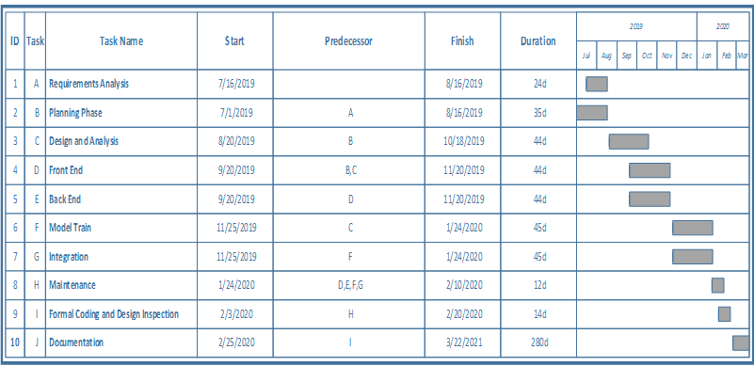

Figure 33 gantt chart

# Chapter # 4

# System Testing

# Chapter 4: System Testing

## Test Cases

### Draw Annotation

|  |  |  |  |  |
| --- | --- | --- | --- | --- |
| **Id** | | TC001 | | |
| **Name** | | draw Annotation | | |
| **Tested By** | | Suleman ahsan | | |
| **Date** | | 6/18/2022 | | |
| **Description** | | For testing the functionality of draw plot on map,its solution and samples. The farmer is attempting to draw plot on map , its solution and samples. | | |
| No | **Test Steps** | | Expected Result | **Actual** |
| 1 | Farmer login | | Farmer is redirected to map page . | Pass |
| 2 | Farmer select tool from association. | | Farmer will draw shapes according to the boundary of the farm | Pass |

Table 18 Test case –Draw Annotation

### Sign In

|  |  |  |  |  |
| --- | --- | --- | --- | --- |
| **Id** | | TC002 | | |
| **Name** | | Sign In | | |
| **Tested by** | | Muhammad Zafar khan | | |
| **Date** | | 6/18/2022 | | |
| **Description** | | Test Functionality of sign in. | | |
| **No** | **Steps** | | **Expected Result** | **Actual Result** |
| 1 | User enter invalid email but valid password and click on login button | | Error message will be shown to user related to invalid email. | Pass |
| 2 | User enter valid email but invalid password and click on login button | | Error message will be shown to user related to invalid password. | Pass |
| 3 | User enters valid email and password and click on login button. | | Login successful and redirected to dashboard. | Pass |
| 4 | User clicks on the forgot password link and gives his email and clicks on the submit button. | | Email should be sent from server to user with reset password link. | Pass |

Table 19 Test case – Sign In

### Subscription

|  |  |  |  |  |
| --- | --- | --- | --- | --- |
| **Id** | | TC002 | | |
| **Name** | | Subscription | | |
| **Tested by** | | Salman ahsan | | |
| **Date** | | 6/18/2022 | | |
| **Descr**  **iption** | | Test case for checking the functionality of subscription. The farmer is attempting to subscribe  weekly , monthly subscriptions. | | |
| No | **Steps** | | **Expected Result** | **Actual Result** |
| 1 | Farmers will click on the subscription button. | | New window will open and the farmer will put his payment method. | Pass |
| 2 | Farmers will click on the dashboard. | | After paying fees and farmer will given access to dashboard | Pass |

Table 20 Test case –Subscription

### Logout

|  |  |  |  |  |
| --- | --- | --- | --- | --- |
| **Id** | | TC004 | | |
| **Name** | | Logout | | |
| **Test by** | | Muhammad Zafar khan naizi | | |
| Date | | 6/18/22 | | |
| **Description** | | Logout from the system. | | |
| **No** | **Steps** | | **Expected Result** | **Actual Result** |
| 1 | * After successfully login in to the account, user click on profile icon, Logout button will be visible to the user. | | * After successfully login in to the account ,user click on profile icon ,Logout button will be visible to the user. | Pass |
| 2 | User click on logout button, user is redirected to the login page. | | * User is redirected to the login page. | Pass |
| 3 | User tries to Go to dashboard directly putting url. | | User is redirected to the login page until user login with valid credentials. | Pass |
| 4 | User’s tries to login with unauthorized IP address. | | * If unauthorized IP tries to make a request user is logout. | Pass |

Table 21 Test case –Logout

### Chat

|  |  |  |  |  |
| --- | --- | --- | --- | --- |
| **Id** | | TC005 | | |
| **Name** | | Chat | | |
| **Test by** | | Muhammad Zafar khan naizi | | |
| Date | | 6/18/22 | | |
| **Description** | | Chat with Admin | | |
| **No** | **Steps** | | **Expected Result** | **Actual Result** |
| 1 | * User clicks on chat icon chat box will be open and user send message to admin. | | * Message will be send to admin | Pass |
| 2 | User edit or deleted message,. | | * Message will be deleted. | Pass |
| 3 | User can send 300 words of chat in one message | | Message is send to the end user. | Pass |
| 4 | Admin and user both can see the status of them whether they are online or offline. | | * Status is shown to the users. | Pass |

Table 22 Test case Chat

### Admin Manage Farmer Data

|  |  |  |  |  |
| --- | --- | --- | --- | --- |
| **Id** | | TC006 | | |
| **Name** | | Chat | | |
| **Test by** | | Muhammad Zafar khan naizi | | |
| Date | | 6/18/22 | | |
| **Description** | | Manage Farmer data | | |
| **No** | **Steps** | | **Expected Result** | **Actual Result** |
| 1 | * Admin after login is redirected to dashboard and see farmer’s data. | | * Admin can see farmers data. | Pass |
| 2 | Admin delete edit or modify farmer’s data. | | * Data is modified. | Pass |
| 3 | Admin send notification and message to the users. | | Message is send to the users. | Pass |
| 4 | Admin edit his profile image and email. | | * Profile image and email is updated | Pass |

Table 23 test case Admin Manage Farmer Data

### Blog

|  |  |  |  |  |
| --- | --- | --- | --- | --- |
| **Id** | | TC007 | | |
| **Name** | | Blog | | |
| **Test by** | | Muhammad Zafar khan naizi | | |
| Date | | 6/18/22 | | |
| **Description** | | Admin will write blog. | | |
| **No** | **Steps** | | **Expected Result** | **Actual Result** |
| 1 | * Admin after login is redirected to dashboard and see blog section | | * Admin can see Blog link. | Pass |
| 2 | Admin will write blog edit blog posts, including adding text, images, and other media, as well as formatting the posts. | | * Blog will bi posted. | Pass |
| 3 | After blog is posted it will be shown on frontend | | Users can read blog posts. | Pass |

Table 24 Test case Blog

# Chapter #5

# Conclusion

# Conclusion

## Problems faced and lessons learned

There are many crop yield estimation techniques which are used in estimation. The useful and effective one is the use of geospatial data and use of technologies satellite imagery and remote sensing. The problems occur when the remote sensing data that we used to estimate crop yield are insufficient due to many problems such as climate conditions and low temporal resolution. So we face a problem in this yield estimation technique. Lack of sensory data is no longer a barrier to management and decision makers in the agricultural sectors. We should therefore create an optimized model that can measure yield by increasing the availability of remote sensor data. We also have to develop a model using a well-known algorithm, and the Regional method of Indirect Reduction Ratio that equals the data obtained from exponential calculations.

## Project summary

The aim of a web portal for yield prediction and health analysis using remote sensing data is to provide a platform for users to access and analyze remote sensing data in order to predict crop yields and assess the health of crops. By analyzing remote sensing data, it is possible to make predictions about crop yields and identify any potential issues that may affect crop health. A web portal would provide a user-friendly interface for accessing and analyzing this data, making it easier for farmers, researchers, and other users to make informed decisions about crop management and production. This application provide farmers with useful information about their land / fields, which helps them to manage their farms better and improve their products, while This Application is a solution to better manage your farm(s) and optimize their production levels. Farmers can do yield estimation and check crop health from this website. This will increase production of yield and be very helpful and beneficial for the farmers. This will be done through proprietary imagery-based algorithms to give farmers a clear image of the nature and state of their soil/farm. Through this application farmers can track weather and take proper actions monitor the temperature, humidity of the soil and can scan the weekly health status of their crops.

## Future work

This website will be maintained so that bugs and technical issues are removed on time. The UI interface and security will be improved with the time. We will add new features like crop health analyses etc so that farmers can get more benefits for this website. We will also keep updating the database and so that we grow our project on a large scale with the passage of time we will also add new features,we will also deploy this website on different platforms like Heroku etc and make this app available for people to use it. We will also add feedback feature in this app that users can give feedback about results.

# Chapter #6

# References

# References

[1]   Ziliani, M. G., Altaf, M. U., Aragon, B., Houborg, R., Franz, T. E., Lu, Y., ... & McCabe, M. F. (2022). Early season prediction of within-field crop yield variability by assimilating CubeSat data into a crop model. *Agricultural and Forest Meteorology*, *313*, 108736.

[2]  Ferencz, C., Bognar, P., Lichtenberger, J., Hamar, D., Tarcsai, G., Timár, G., ... & Ferencz-Árkos, I. (2004). Crop yield estimation by satellite remote sensing. *International Journal of Remote Sensing*, *25*(20), 4113-4149.

[3]  Awad, M. M. (2019). An innovative intelligent system based on remote sensing and mathematical models for improving crop yield estimation. *Information Processing in Agriculture*, *6*(3), 316-325.

[4] Maia, R. F., Netto, I., & Tran, A. L. H. (2017, October). Precision agriculture using remote monitoring systems in Brazil. In *2017 IEEE Global Humanitarian Technology Conference (GHTC)* (pp. 1-6). IEEE.

[5]Acedo, G. G. (2020, January). Data Visualization and Analysis of Agricultural Land Use System Employing GI. In *Proceedings of 2020 the 6th International Conference on Computing*

*and Data Engineering* (pp. 121-125).

# Chapter #7

# Plagiarism Report

# Plagiarism Report

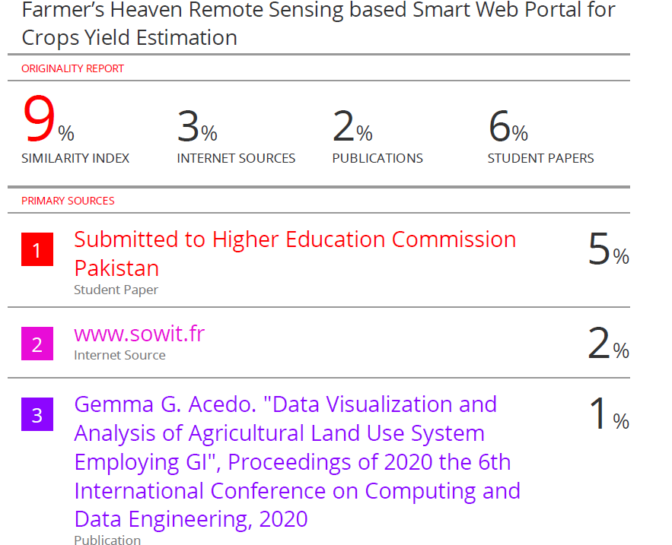

# Chapter #8

# Screenshots

# Screenshots:

### Change Password

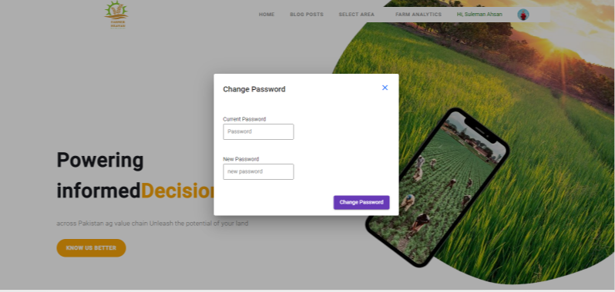

Select Area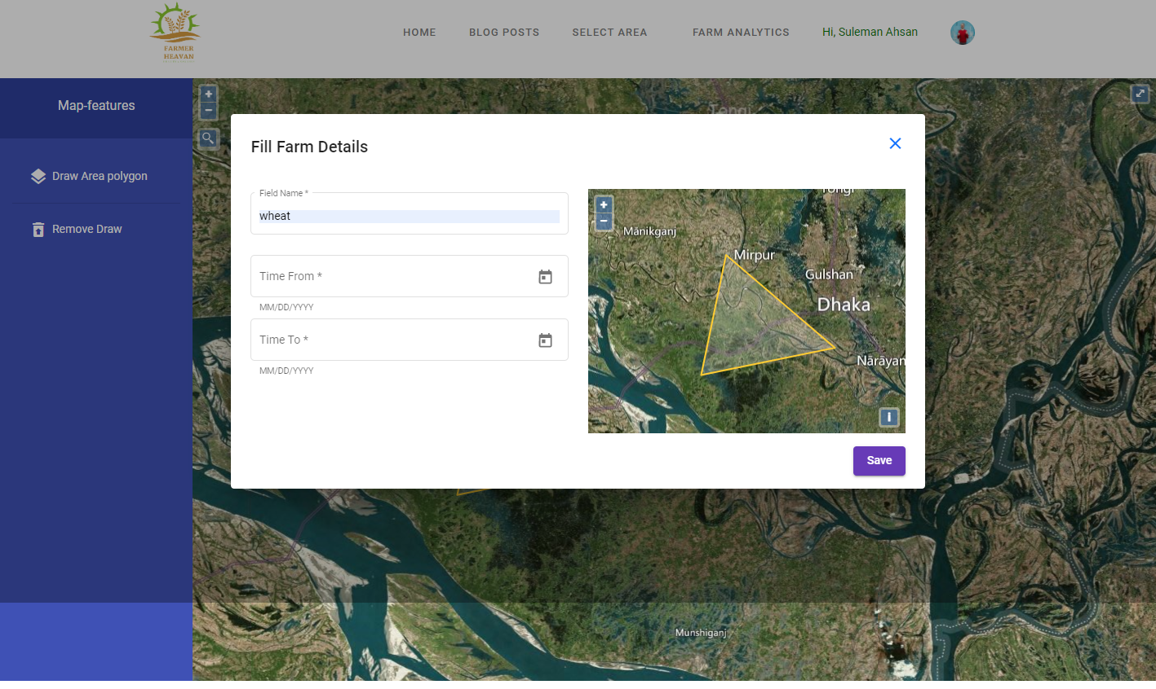

Farm Details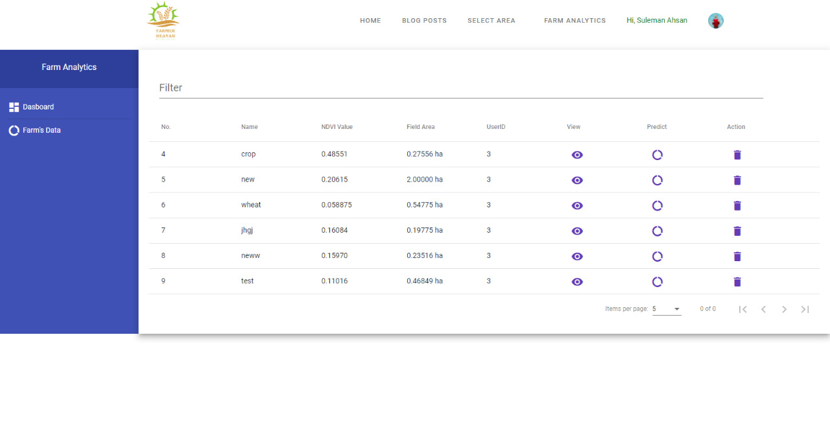

Map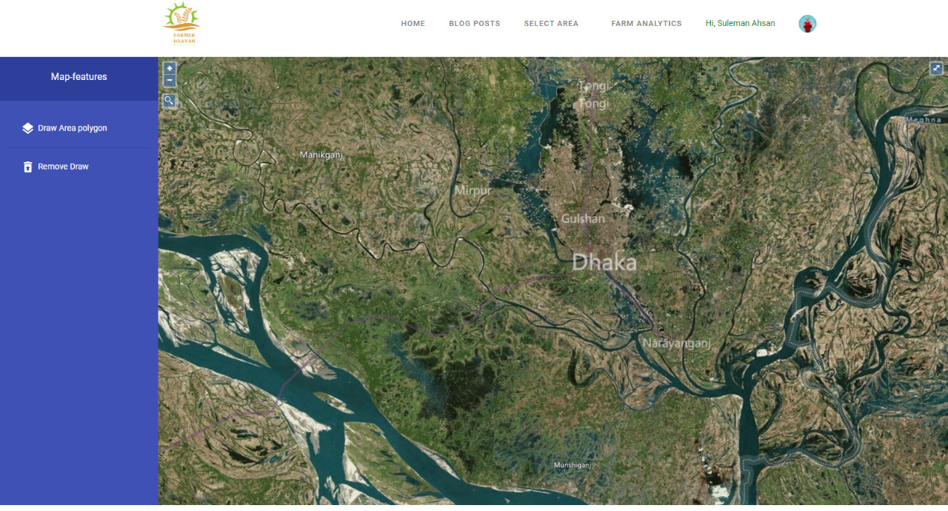

Registration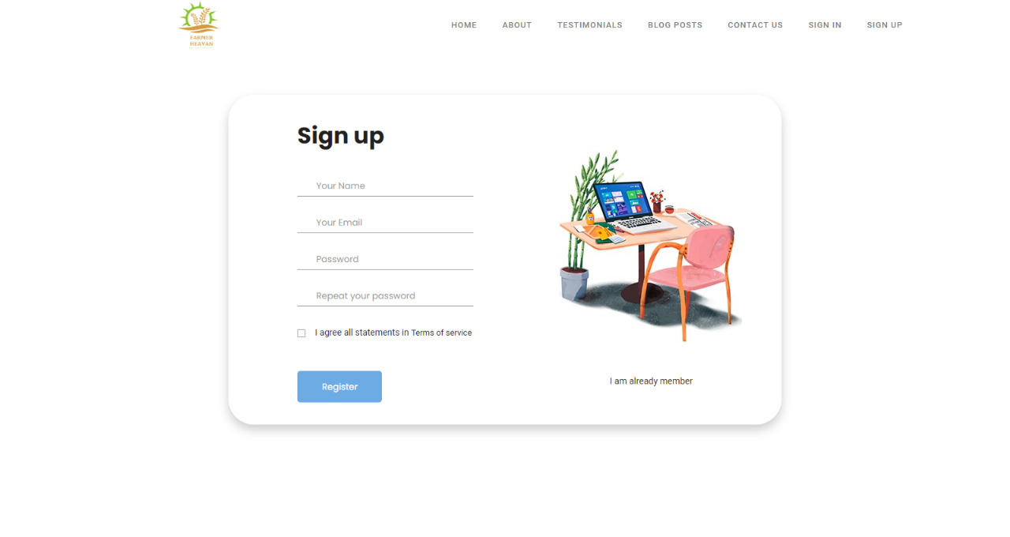

User Sign in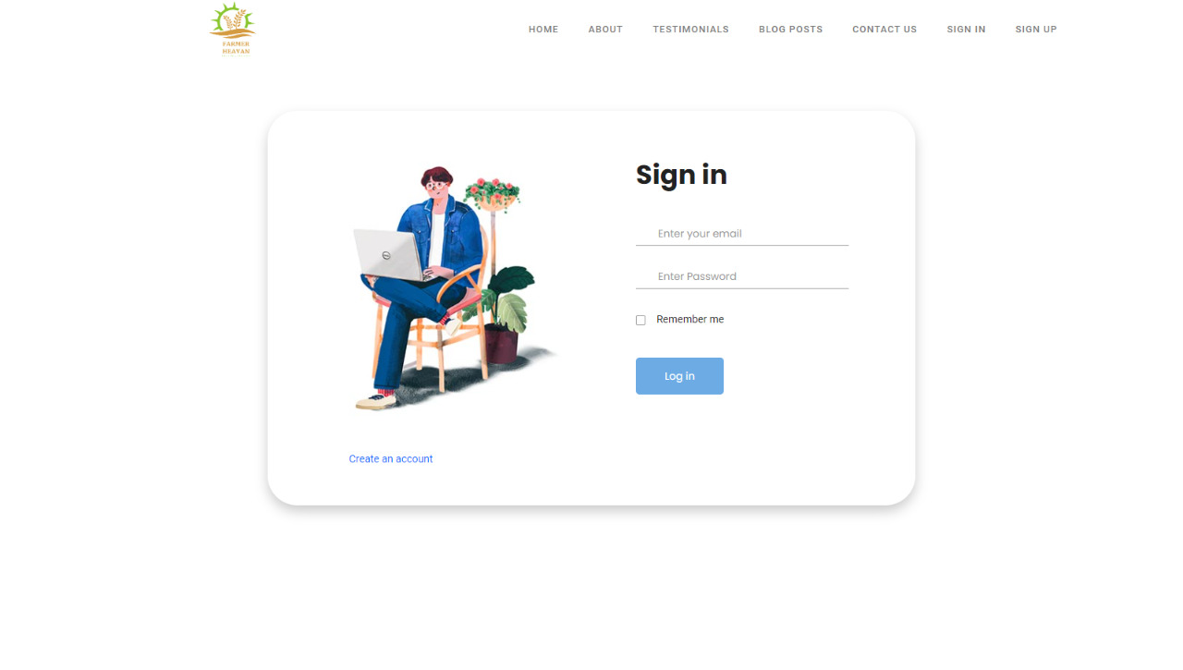

Admin Login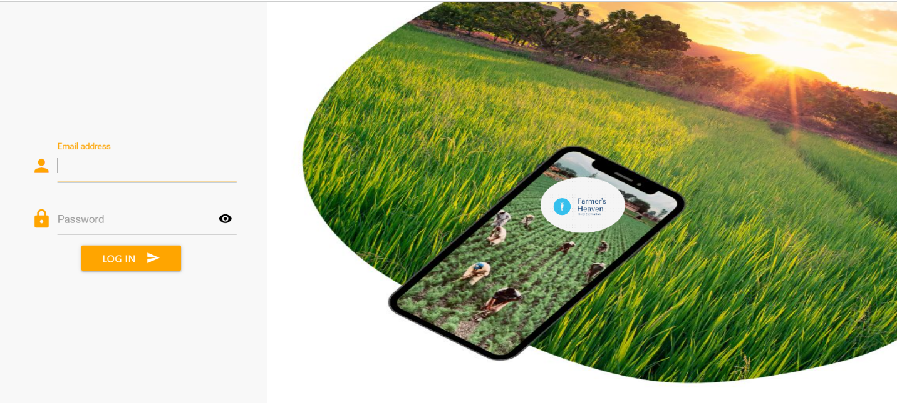

Admin Dashboard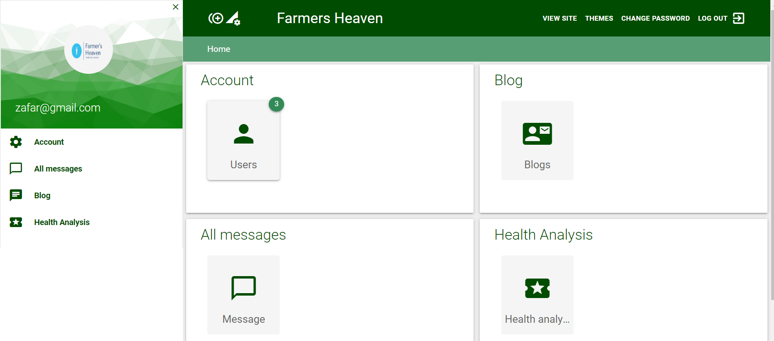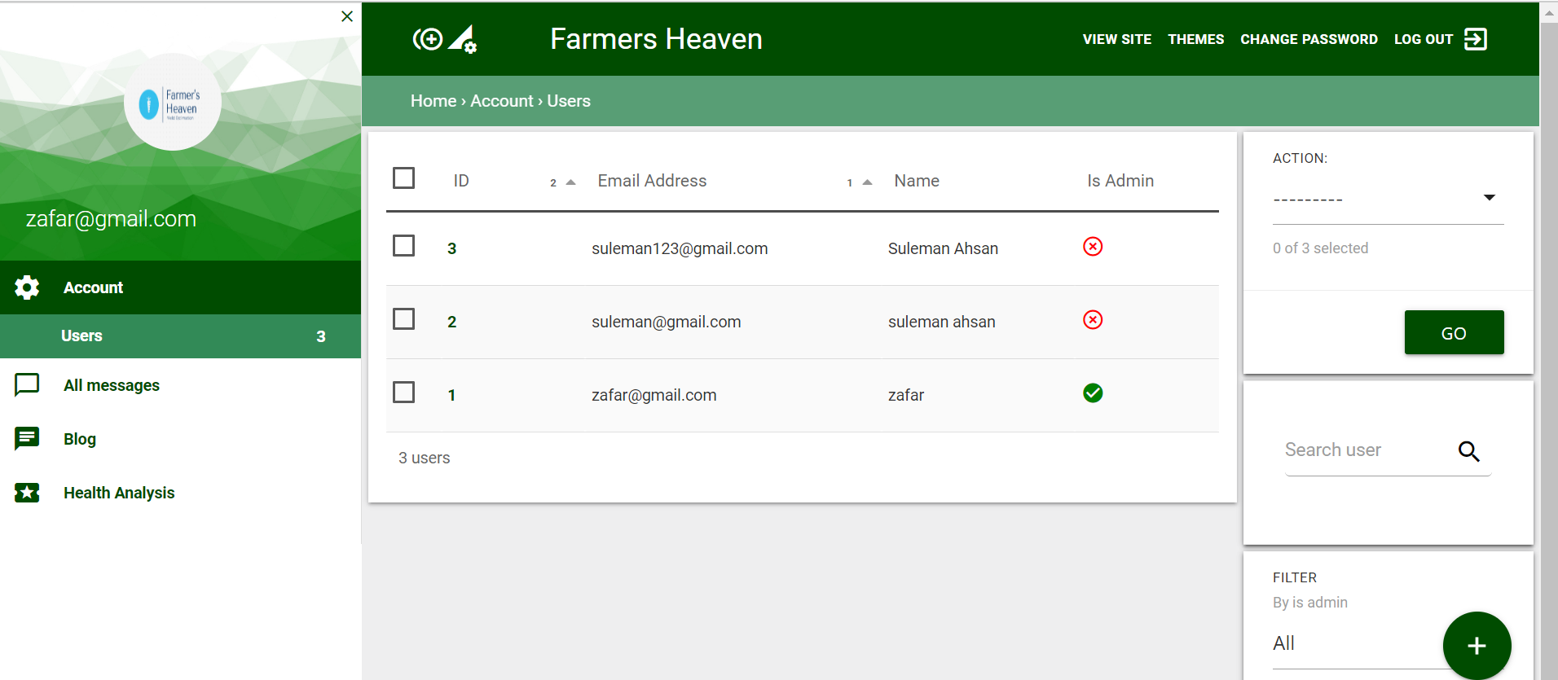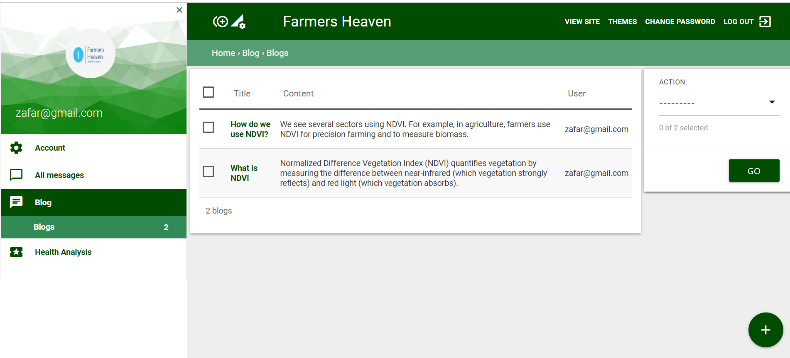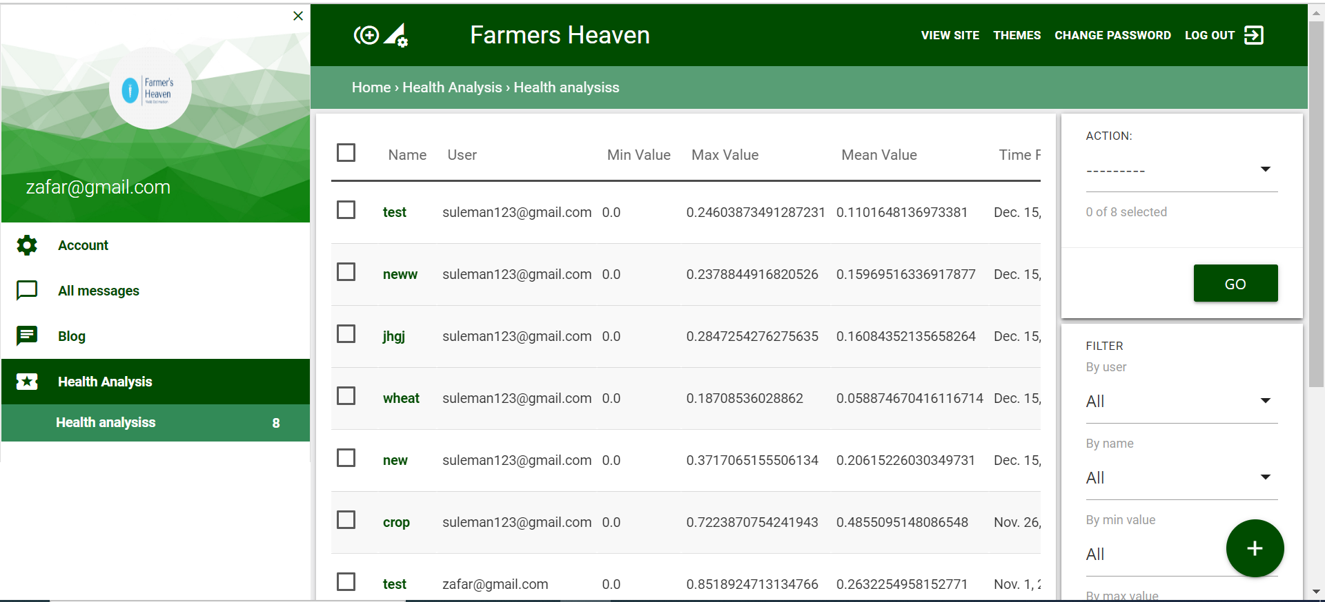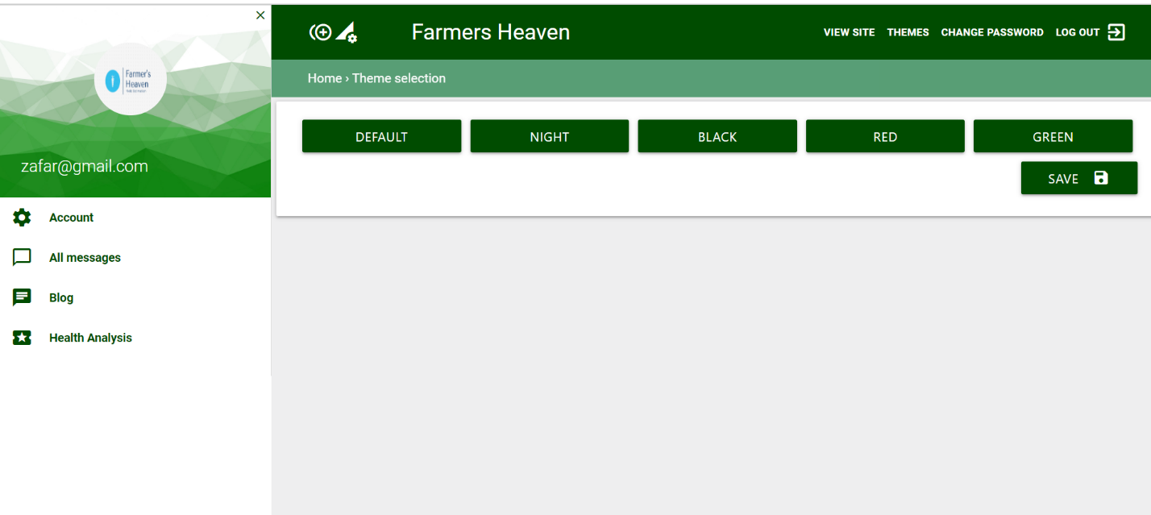

HomePage

